**1)**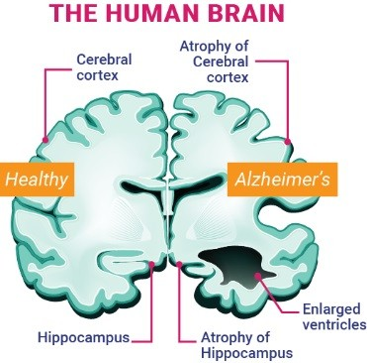

**comparision of normal brain and AD brain.** **Nonetheless, due to the variety of medical tests available, manual comparison, visualization, and interpretation of data is challenging and time-consuming. MRI scan classification is an effective method for predicting brain diseases with high accuracy, but it is also a difficult undertaking. However, new methods for Alzheimer's early diagnosis have been proposed.**

2) **Process diagram of ml technique for classification of Alzheimer’s disease.**

Dataset

Image

Processing

Feature Extraction

Train

Test

Feature

Selection

Machine

Learning Model

Alzheimer’s Disease Classification

# 3) DEEP LEARNING-BASED METODS

**Comparison between various researchers result and methods**

|  |  |  |  |
| --- | --- | --- | --- |
| **Author** | **Method** | **Algorithm** | **Results** |
| “E.M. Alkabawi et al.[36] | “Features extraction” and “classification” | CNN + LR | **74.93%** |
| Laske et al.[37] | AD and NC | SVM | **81.7%** |
| ‘T. Glozman” et al. [38] | AD classification | “ImageNet Transfer Learning” | **83.5%** |
| Cui et al. [39] | AD diagnosis | RNN | **89.7%** |
| Smith Vikos et al. [40] | AD and NC | SVM | **90.3%** |
| S. Wang, et al. [41] | AD classification | Transfer Learning | **90.6%** |
| “Afzal. S” et al. [42] | “Multiclass AD classification” | “SVM” | **92.4%** |
| Muazzam et al. [43] | AD | Transfer Learning | **92.85%** |
| Gunawerdena et al. [44] | AD | CNN | **96%** |
| “J. Akhila et al”. [45] | “Classification of AD” | “Feedforward NN” | **97.5%** |